Ideation Phase
Define the Problem Statements

Date | 20 February 2026
Team ID | LTVIP2026TMIDS41611
Project Name | OrderOnTheGo: Your On-Demand Food Ordering Solution
Maximum Marks | 2 Marks

Customer Problem Statement Template:
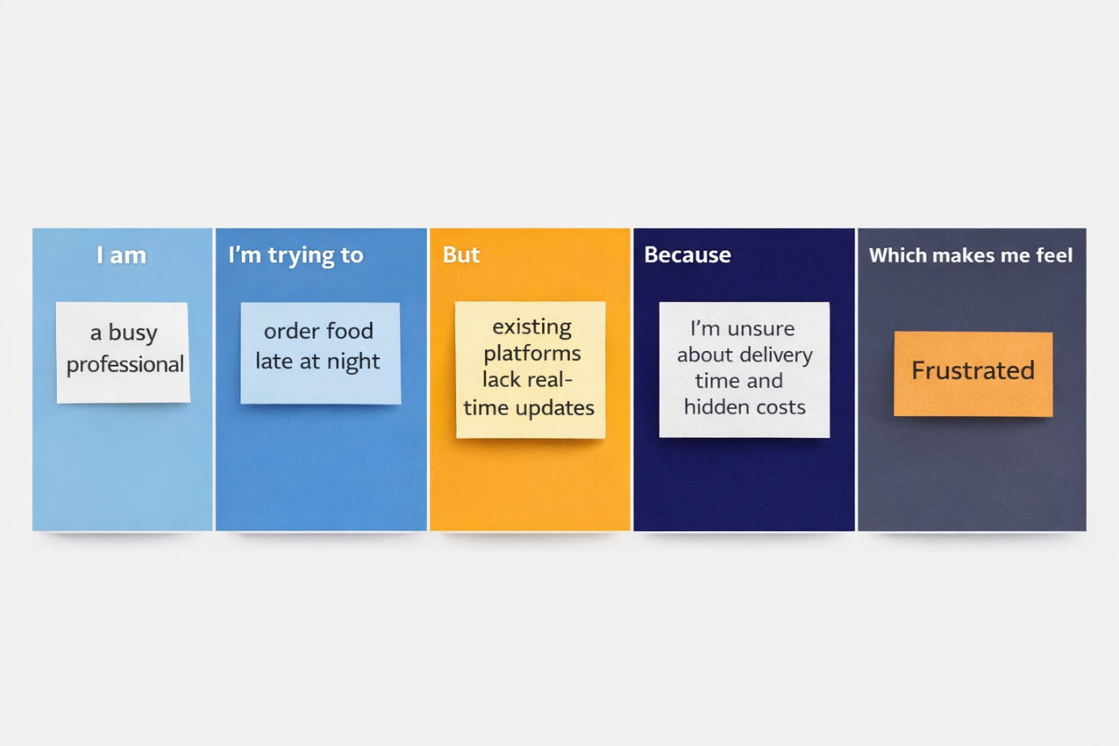

Problem Statement (PS) | I am (Customer) | I’m trying to | But | Because | Which makes me feel
PS-1 | A busy working professional | Order food quickly after work | I struggle to find reliable restaurants open late at night | Many platforms don’t clearly show availability or delivery time | Frustrated and tired
PS-2 | A hungry college student | Get affordable food delivered fast | I can’t easily compare prices and delivery times | Some apps hide extra charges until checkout | Confused and disappointed
PS-3 |  | Reorder my favorite meals easily | I have to search again every time | Previous orders are not clearly saved or accessible | Annoyed and inconvenienced
  A regular food customer
PS-4 |  | Manage my menu and orders efficiently | I don’t have a simple dashboard to update items or track revenue | Existing systems are complex and not user-friendly | Overwhelmed and stressed
  A restaurant owner
PS-5 | A customer placing an online order | Pay securely and confidently | I worry about payment failures or fraud | Not all platforms provide clear payment verification | Anxious and uncertain
PS-6 | A food delivery customer | Track my order in real time | I don’t know the exact delivery status | Some systems don’t update order progress properly | Impatient and worried

